ASSIGNMENT 1
BATCH NO : B1-1M3E
Name : P.ABIRAMI

Make a smart home in Tinkercad , Using 2+ sensors , Led , Buzzer in single code and circuit

Circuit Diagram
Before Started Simulation

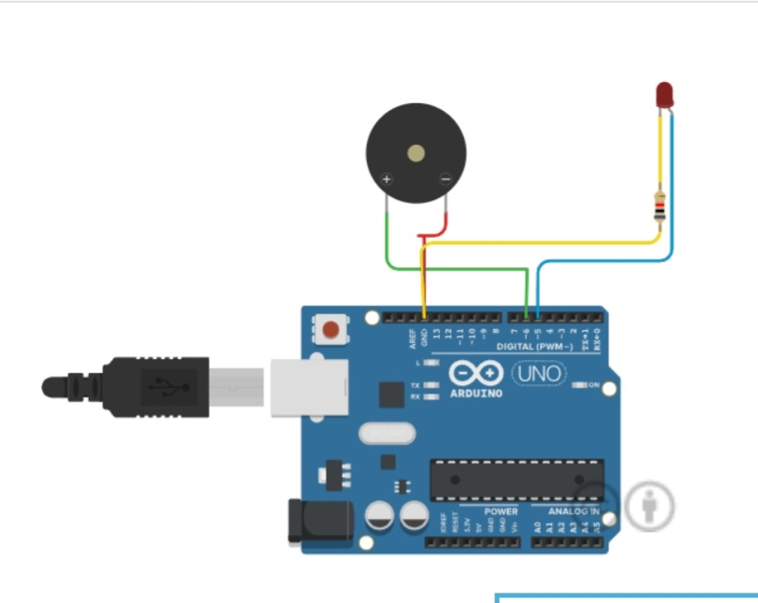

After Started Simulating

Circuit Code

int trigger_pin=2;
int echo_pin=3;
int buzzer_pin=10;
int time;
int distance;
float x,y,z,temp;
void setup()
{
Serial.begin(9600);
pinMode(trigger_pin,OUTPUT);
pinMode(echo_pin,INPUT);
pinMode(buzzer_pin,OUTPUT);
pinMode(8,INPUT);
pinMode(5, OUTPUT);
pinMode(6,OUTPUT);
pinMode(A5,INPUT);
pinMode(A4,INPUT);
Serial.begin(9600);
}
void loop()
{
x=digitalRead(8);
y=analogRead(A5);
z=analogRead(A4);
Serial.println(x);
Serial.println(y);
Serial.println(z);
temp=(double)z /1024;
temp=temp*5;
temp=temp-0.5;
temp=temp*100;
if ( (x>0) )
{
if ((y<550)&&(temp<30))
{
digitalWrite(5,HIGH);
digitalWrite(6,HIGH);
}
else if((y<550)&&(temp<30))
{
digitalWrite(5,HIGH);
digitalWrite(6,LOW);
}
else if((y>550)&&(temp>30))
{
digitalWrite(5,LOW);
digitalWrite(6,HIGH);
}
else if((y>550)&&(temp<30))
{
digitalWrite(5,LOW);
digitalWrite(6,HIGH);
}
}
else if((y>550)&&(temp<30))
{
digitalWrite(5,LOW);
digitalWrite(6,LOW);
}
}

